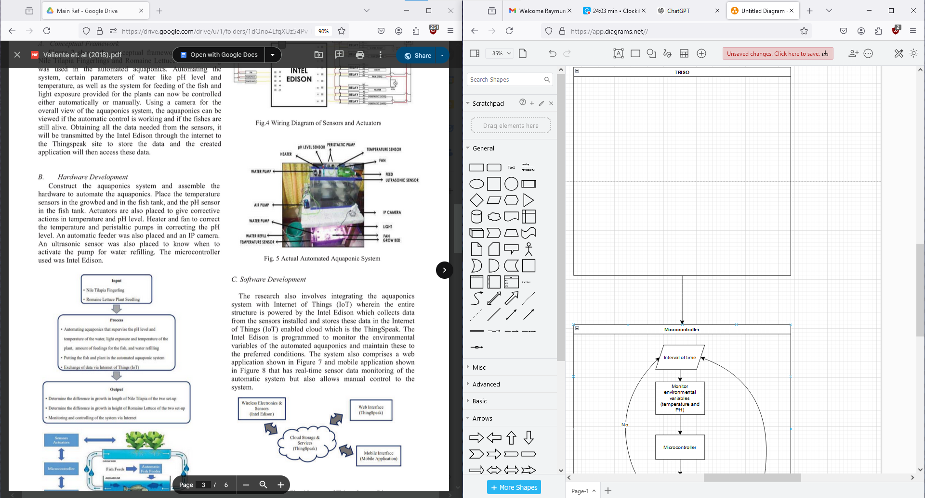

Shouldn’t this be three values:

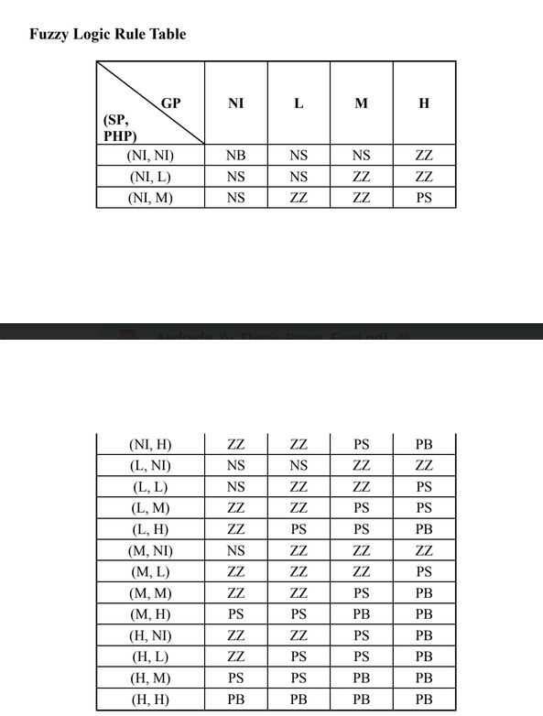

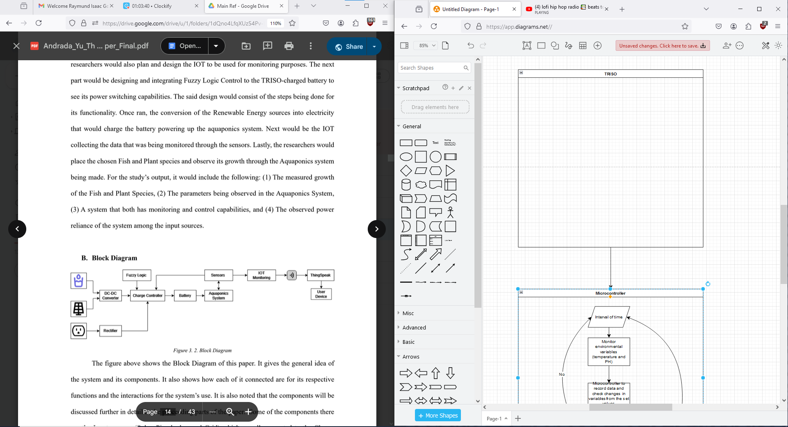

Draft Flowchart:

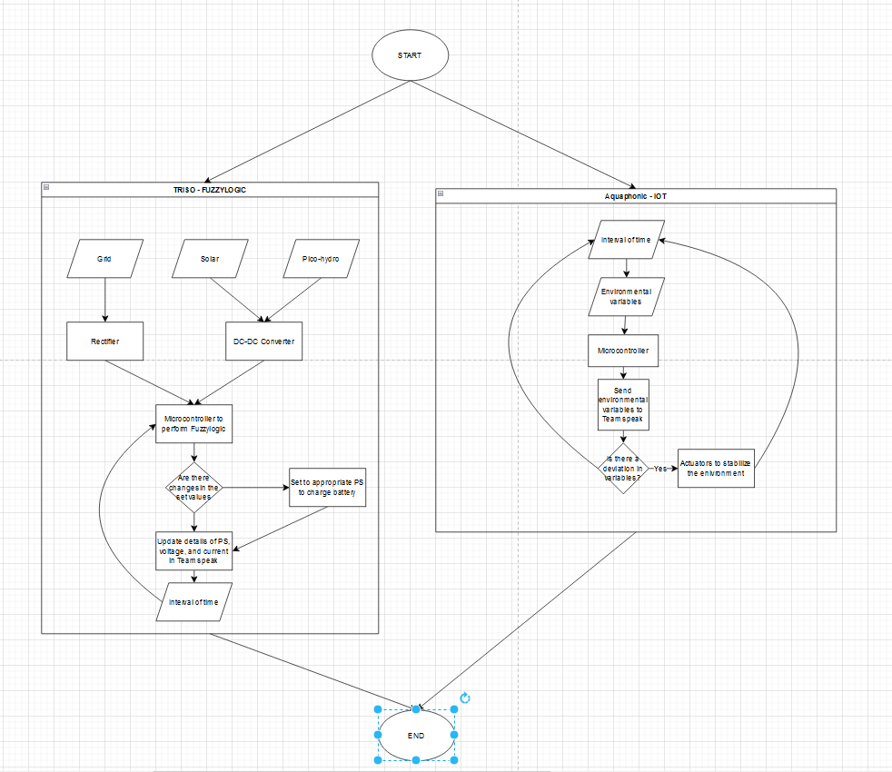

Final Draft Flowchart:

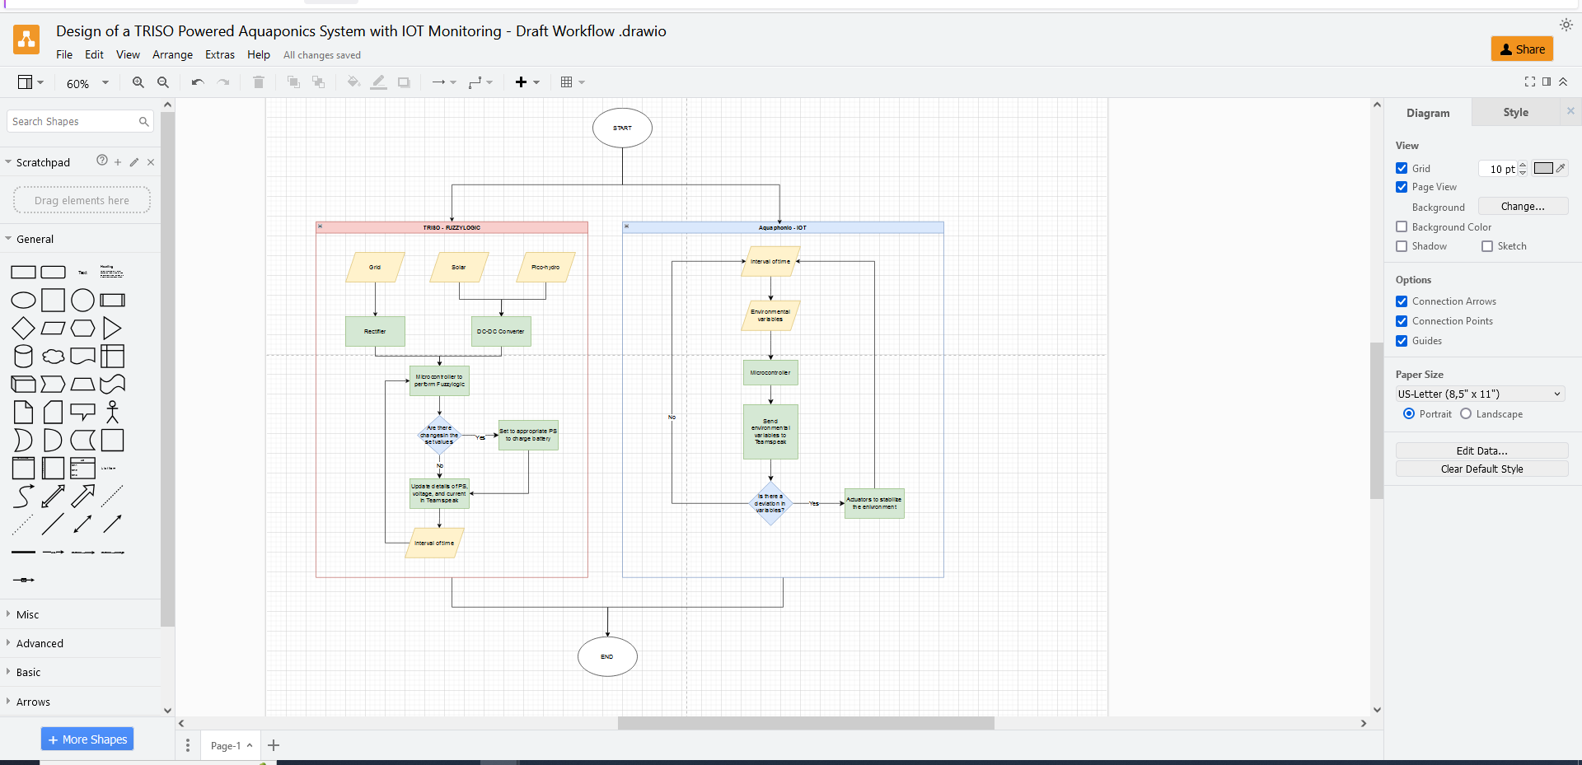

Hi, I have created a draft workflow, based on the paper you have submitted. This is not yet final and will be changed based on future discussions po.

Pakisabi na lng po if ever may questions kayo sa draft workflow